**Users with Templates**

Objectives:

* Practice incorporating models into the whole MTV (MVC) architecture

The shell practice in the previous assignment allowed us to focus just on the Model portion of the MTV architecture. But while the shell is very useful, it can be difficult to visualize the data being saved and retrieved and can be tedious adding data in manually. Let's add Templates and Views back into the mix!

Working with the same Users project and app from the previous assignment, add a route that renders a template that looks something like this:

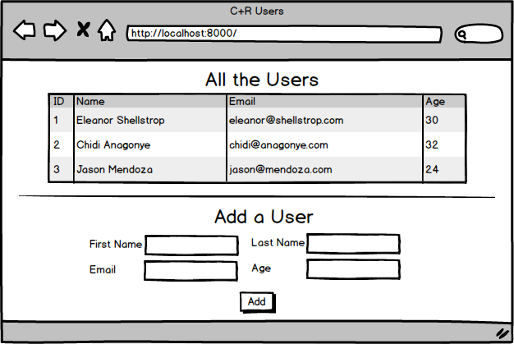

* Top of Form
* Add a template to your app
* Add a route that renders this template and have it display a table with all the data from the database
* Add a form to the page
* Add a route that processes the form information, adds it to the database, and then redirects to display the template
* Bottom of Form